|  |  |
| --- | --- |
| Assignment Cover Sheet | |
| Candidate Number | 730068016 |
| Module Code | BEMM783 |
| Module Name | Supply Chain Analytics |
| Assignment Title | Supply Chain Analytics Individual Assignment |

*Within the Business School we support the responsible and ethical use of GenAI tools, and we seek to develop your ability to use these tools to help you study and learn. An important part of this process is being transparent about how you have used GenAI tools during the preparation of your assignments.*

*The below declaration is intended to guide transparency in the use of GenAI tools, and to assist you in ensuring appropriate referencing of those tools within your work.*

*The following GenAI tools have been used in the production of this work:*

*[please specify]* ………………………………………..

  *I have used GenAI tools for brainstorming ideas.*

*I have used GenAI tools to assist with research or gathering information.*

*I have used GenAI tools to help me understand key theories and concepts.*

*I have used GenAI tools to identify trends and themes as part of my data analysis.*

  *I have used GenAI tools to suggest a plan or structure of my assessment.*

*I have used AI tools to give me feedback on a draft.*

*I have used GenAI tool to generate images, figures or diagrams.*

*I have used AI tools to proofread and correct grammar or spelling errors.*

*I have used AI tools to generate citations or references.*

  *Other [please specify] …………………………………………………………………………………………………………………*

  *I declare that I have referenced use of GenAI tools and outputs within my assessment in line with the* [University referencing guidelines](https://eur03.safelinks.protection.outlook.com/?url=https%3A%2F%2Flibguides.exeter.ac.uk%2Freferencing&data=05%7C02%7Cesm.buildingone%40exeter.ac.uk%7Cf648da2e0e514f17ff0808dcef4ae06d%7C912a5d77fb984eeeaf321334d8f04a53%7C0%7C0%7C638648352064065071%7CUnknown%7CTWFpbGZsb3d8eyJWIjoiMC4wLjAwMDAiLCJQIjoiV2luMzIiLCJBTiI6Ik1haWwiLCJXVCI6Mn0%3D%7C0%7C%7C%7C&sdata=XtT64F9dPrvOQT2VctmEQFhuY7otvEvyQ8PLT5lzbus%3D&reserved=0)*.*

MSc Business Analytics

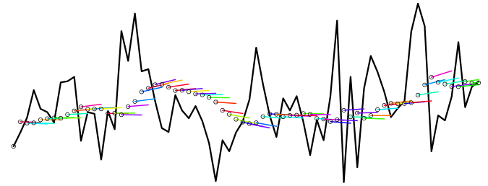Supply Chain Analytics

Exploring Forecasting Methods

Student ID# 730068016

Word Count: 1976

**Contents**

Section 1: Exploring the Data 4

Section 2: Forecasting Methods and Recommendations 6

Section 3: Executive Report 10

References 11

# **Section 1: Exploring the Data**

**Introduction**

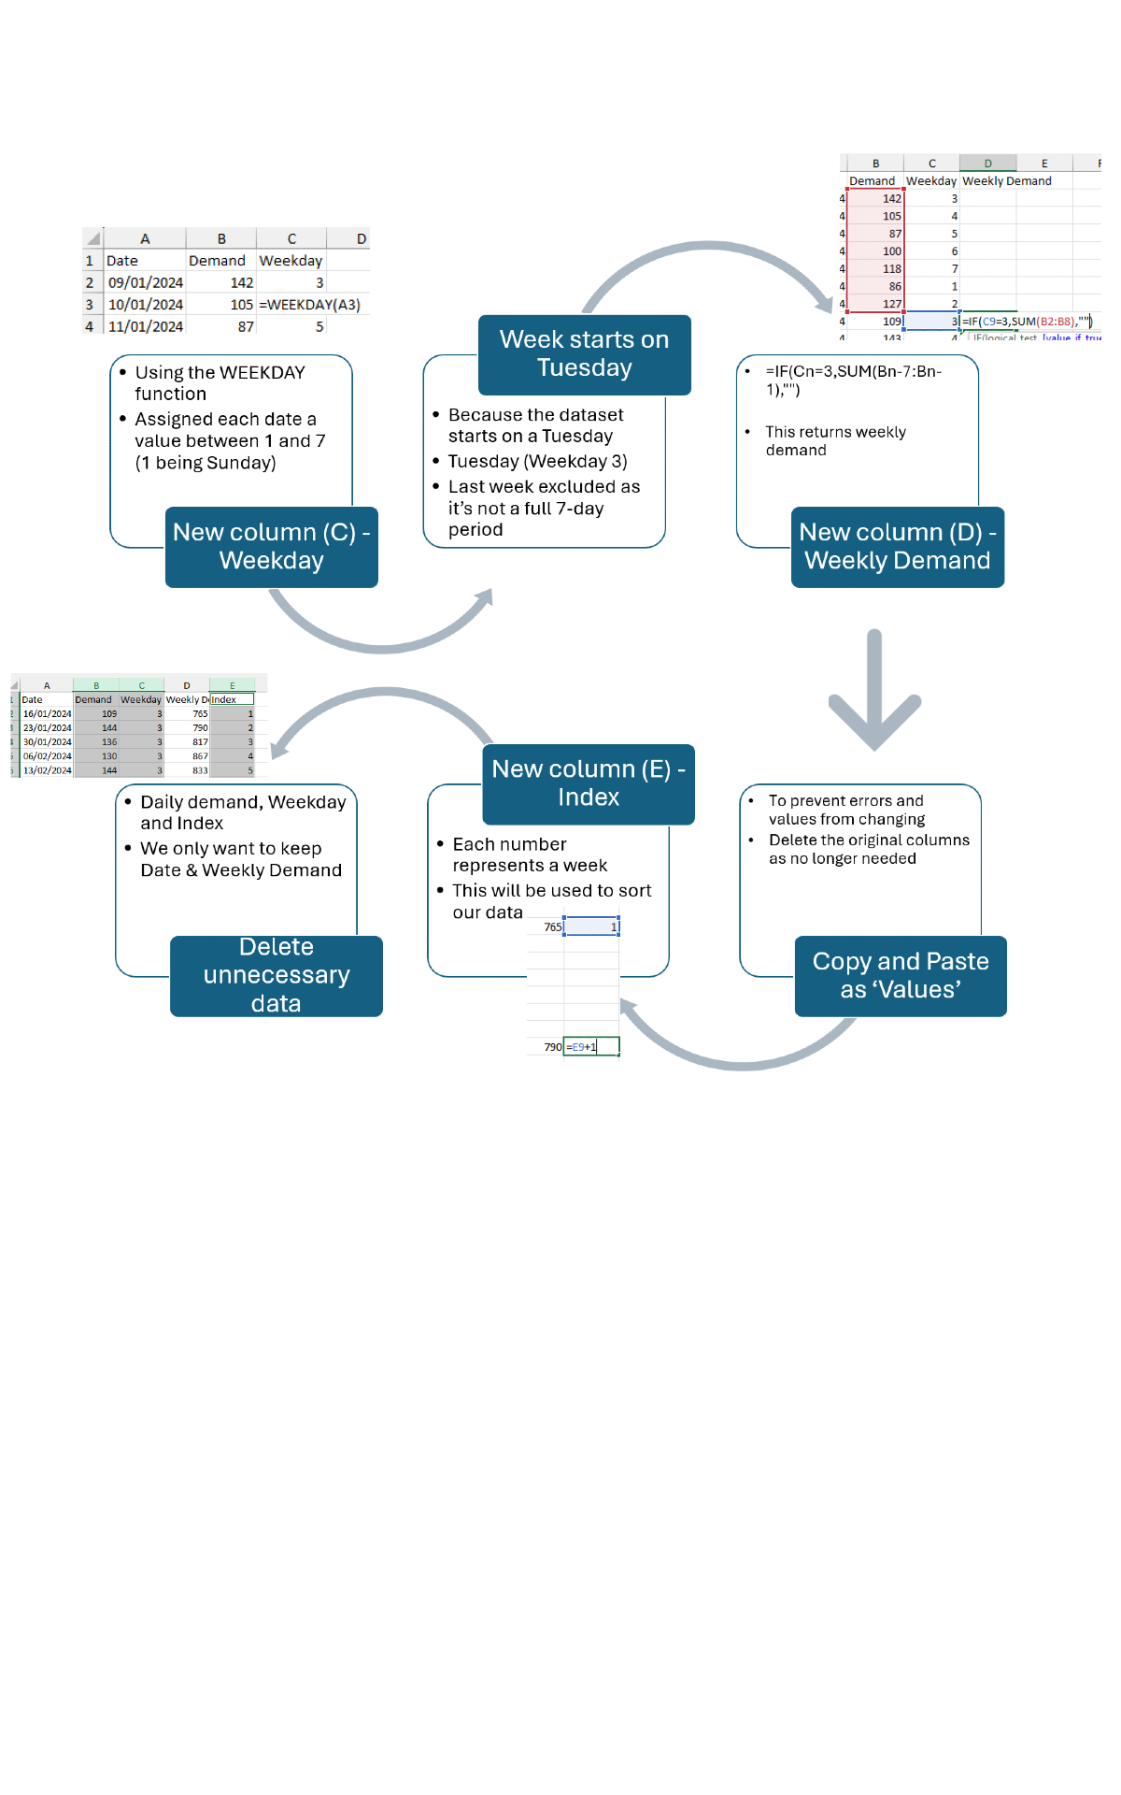The original daily demand for yogurt was converted into weekly demand to match the company’s weekly production schedule, as depicted in Figure 1. Given that the demand is for yogurt, a perishable dairy product, a lead time of 1 week has been chosen. For the analysis of the dataset, an R-shiny Forecast Explorer will be used (Disney, 2024).



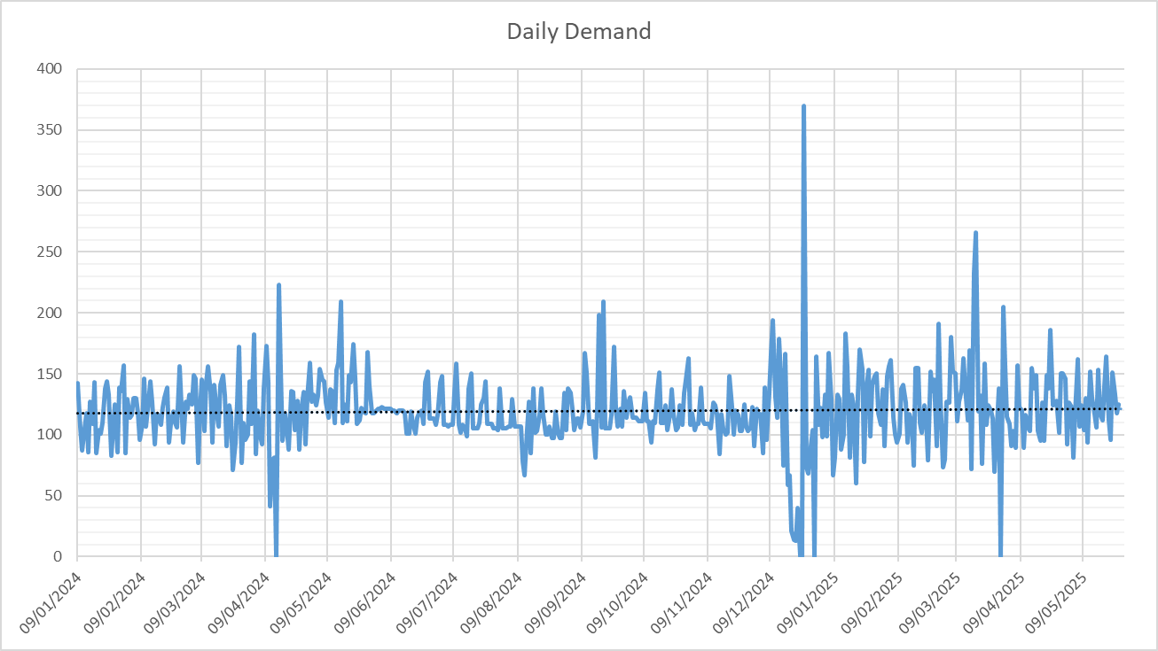**Data overview**

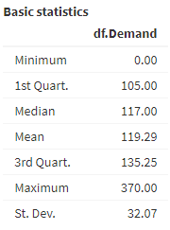





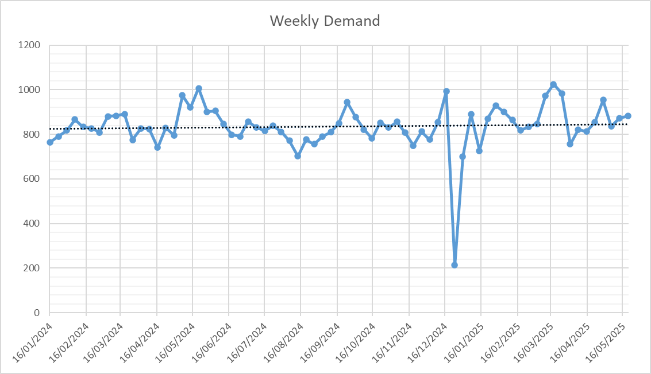

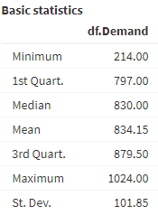





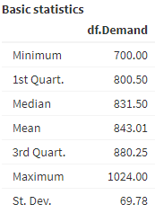



Due to the large number of individual data points, the daily demand time series (Figure 2) is challenging to interpret. In contrast, the weekly demand time series (Figure 4) aggregates daily fluctuations, smoothing out short-term variations that could otherwise obscure underlying trends or potential seasonal patterns (Borucka, 2023, p. 3). For this reason, the forecasting methods will only be applied to the weekly demand data, which provides a clearer view of demand.

A notable outlier in mid-December in Figure 4 will be removed, as it distorts the graph and could lead to inaccurate forecasts (see Figure 6). To avoid issues such as excess inventory or stockouts during this period, manual adjustments to forecasts in December are recommended (Disney, 2023a, Chapter “Manual interventions”).

A linear regression model applied to this data demonstrates limited explanatory power, with an adjusted R² of 0.0154, an intercept of 822.05, and a gradient of 0.5904. Testing a second-order polynomial further reduced the adjusted R² to 0.0137, reinforcing the lack of a strong trend or seasonality in demand.

There are no regular peaks or troughs at predictable intervals; instead, the demand appears relatively stable, as evidenced by the spread and distribution of the data (Figure 7). The standard deviation (69.78) is low relative to the range (700–1024), indicating that values cluster consistently around the mean (843.01) with few extreme fluctuations. The proximity of the quartiles (1st Quartile = 800.5 and 3rd Quartile = 880.25) to the median (831.5) further supports this stability, as demand values show little deviation from the centre.

# **Section 2: Forecasting Methods and Recommendations**

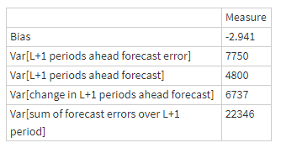Each forecasting method will be benchmarked against the Naïve Method, in which forecasts are simply set equal to the last observed value (see Figure 8).



**Inventory Focus**

To reduce inventory costs, such as storage, management, and depreciation, the primary focus should be on minimising the variance of forecast errors (VE), and then the sum of forecast error variance (SUM) (Disney, 2023a, 2023b). Due to the demand being relatively stable with a subtle upward trend, Holt’s Method was selected as the primary forecasting approach (Disney, 2023a, Chapter “Common forecasting methods”) The target parameters for this model include an α value near zero to maintain stability by aligning forecasts with the global mean of 843.01 (Figure 7) and a moderately high β to capture the gradual upward trend. These parameter targets will help ensure that the model balances stability with moderate responsiveness to trend changes.

****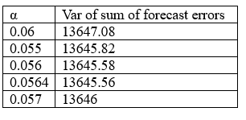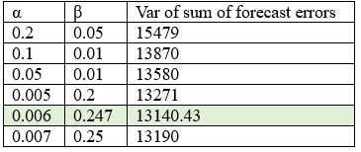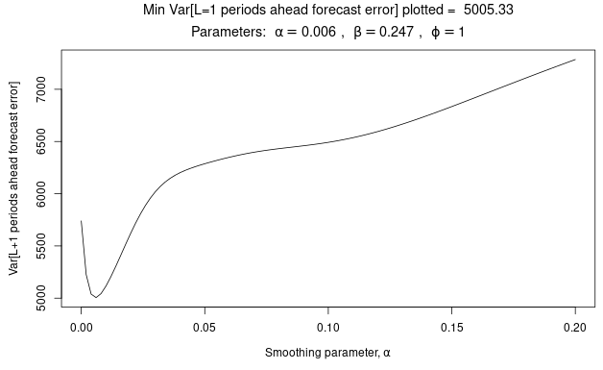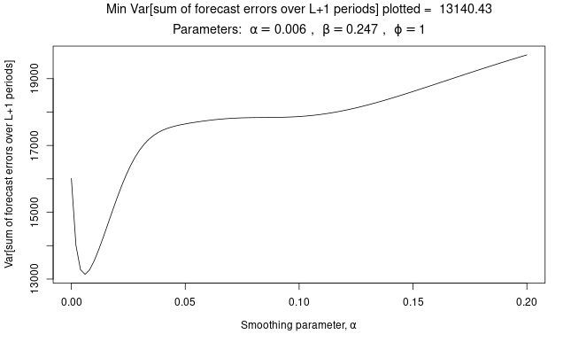By manually selecting different β parameters in the Parameter Explorer tab in the R-shiny, it was found that the optimal values for minimising VE & SUM using Holt’s Method are α = 0.006 and β = 0.247 (Figures 9 & 10). Using Holt’s Method, SUM has decreased by approximately 41.2%, and VE by 35.4%, compared to naïve forecasting (Figure 8). On the other hand, the bias has shifted from -2.941 with the Naïve Method to -11.754 with Holt’s Method, indicating that Holt’s forecasts are likely to underestimate demand more noticeably (Disney, 2023a, Chapter “Tuning the Forecasting Parameters”). However, given that this increase in bias is relatively minor and thus can be easily corrected, it can be considered an acceptable trade-off for the reduction in forecast errors achieved with Holt’s Method. Further parameter testing confirmed the parameters as optimal (Figure 11). Finally, Holt’s Method also outperformed Exponential Smoothing, which produced a higher VE across all values of α due to its inability to account for the increasing trend (Figure 12).





**Capacity Focus**

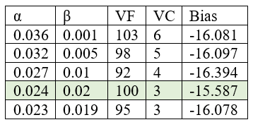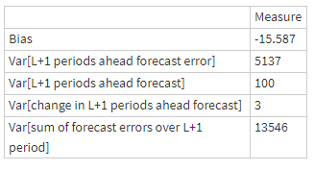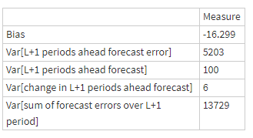To reduce the Bullwhip effect and capacity costs—such as additional storage space or hiring agency staff to handle inventory fluctuations—minimising forecast variance (VF) and the variance of change (VC) is essential (Disney, 2023a, Chapter “Tuning the Forecasting Parameters”). Setting α close to 0 will reduce order variability by limiting the forecast’s sensitivity to short-term demand changes, bringing the Bullwhip ratio closer to unity and lowering the standard deviation of orders (Disney, 2023a, Chapter “Bullwhip and NSAmp in the OUT Policy”). This approach smooths production needs and stabilises capacity requirements, thereby reducing associated costs. Additionally, using Holt’s Method, a moderately low β will produce a smoother forecast that still reflects the underlying demand trend. It is also important to keep in mind that setting α and β too close to 0 can significantly increase the bias, reducing the forecast’s ability to follow the overall pattern of demand over time (Disney, 2023a, Chapter “Tuning the forecasting parameters”). Considering these points, it was decided that an effective set of parameters should keep VF and VC at or below 100, while also minimising bias. First, Exponential Smoothing was deployed to identify an optimal starting α value of 0.036 (Figure 13). To account for the gradual trend increase and reduce forecast bias, Holt’s Method was applied with a further reduction in the initial α value. This adjustment helped maintain bias at a low level, aligning the forecast more closely with observed demand trends. The optimal parameters for Holt’s Method were identified as α = 0.024 and β = 0.02 (Figure 14). To confirm this selection, alternative parameter values were tested (Figure 15), but any adjustments to α or β resulted in increased bias or variance. This underscores the importance of carefully balancing these parameters to achieve the best possible forecast accuracy. Compared to the Naïve Method (Figure 8), Holt’s Method demonstrates a more noticeable bias alongside significant improvements VF and VC.

**Inventory & Capacity Balance**

It is possible to reduce both inventory and capacity costs by choosing a suitable forecasting method. To achieve an optimal balance, it was decided that VF would reach a level of up to 250, bias would remain within ±10, and SUM would reach up to 13,200. This approach ensures both types of costs are considered, but with less emphasis than if each were addressed independently. Through a manual and iterative process, it was found that, surprisingly, the Damped Trend generates the most favourable results. The optimal set of Damped Trend 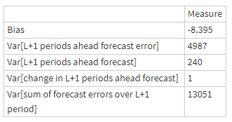parameters was identified as α = 0.01, β = 0.155, and ϕ = 1.01 (see Figure 16). With other parameters unchanged, setting β between 0.14 and 0.17 yielded similarly satisfactory results that remained within the defined boundaries (see Figure 17). The first set of parameters was chosen as the primary example because it sits at the midpoint of the acceptable range, providing an optimal balance between low bias, VE, VF, VC and SUM. The chosen parameters generate lower VE and SUM even 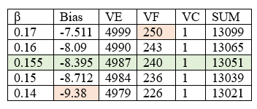than the Holt’s Method used in Inventory Focus. Comparing these results with the Naïve Method (Figure 8) reveals significant improvements across all measures, except in bias, which remains lower with the Naïve Method (-2.941). This may be due to the naïve approach simply projecting the most recent value forward, without adjusting for trends or smoothing, thereby reducing the risk of systematic over- or underestimation. The Damped Trend functions similarly 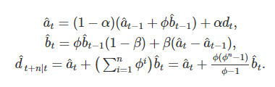to Holt's Method, but instead of projecting future demand as a straight line, it uses a curve (Disney, 2023a, Chapter “Damped Trend”). It is said that this method works best when the demand has an exponential growth or exponential decay over the lead-time and review period (Disney, 2023a, Chapter A close-up of a white background
“Common forecasting methods). It is surprising that the Damped Trend generates such low errors, given that the demand only has a slightly upward linear trend. To further explore this phenomenon, the Damped Trend formula (Figure 18) was carefully analysed. The formula generates estimates of the level (a hat) and the trend (b hat), similar to Holt's Method (Disney, 2023a, Chapter 'Holt’s Method'); however, here the damping parameter ϕ is applied to both, which directly influences the curvature of the forecasted values. This damping effect smooths the trend over time, preventing extreme or unrealistic extrapolations in longer forecasts by gradually reducing the trend's influence. Further research shows that Damped Trend’s conservative approach makes it a reliable benchmark for improving accuracy across varied data patterns (Fildes, Nikolopoulos, Crone, & Syntetos, 2008, p. 1154). In other words, the Damped Trend can deliver optimal results even when demand patterns do not follow a standard exponential trend.

# **Section 3: Executive Report**

**Introduction**

****The main reason for evaluating forecasting methods is to reduce the bullwhip effect—fluctuations in inventory driven by changes in consumer demand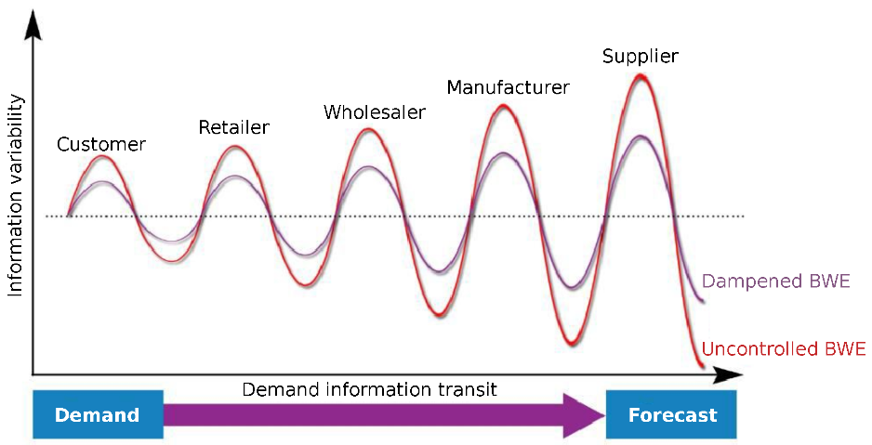 (Moura, de Vleeschauwer, Haesendonck, De Meester, D’eer, De Schepper, Mercelis, & Mannens, 2024, p. 1). This report examines forecasting approaches, including Exponential Smoothing, Holt’s Method and the Damped Trend, to assess their effectiveness in minimising inventory and capacity costs for our yoghurt product. By optimising parameters for each model, this analysis aims to balance forecast stability with targeted cost-reduction strategies. The assumed lead time for the yoghurt is 1 week, as it significantly reduces the Bullwhip effect (Disney, 2023a, Chapter “Bullwhip and NSAmp in the OUT policy”).

**Key Findings**

*Minimise Inventory Costs*

In minimising holding, ordering, spoilage and other inventory costs, the goal is to minimise the variance of forecast errors (VE), which tells us how much forecasts are off from actual results on average; and the sum of forecast error variance (SUM), which adds up all those differences for each forecasted period. Through a manual and iterative process of trying out different parameters, it was found that Holt’s Method with the parameters α = 0.006 and β = 0.247 produced significantly lower VE and SUM than the Naïve Method, in which forecasts are set equal to the last observed value.

*Minimise Capacity Costs*

In minimising overtime, facility expansion, and Bullwhip costs, the priority is to minimise forecast variance (VF), which shows the expected variability in future forecasts; and the variance of change (VC), which measures how much values change over time. This time, the optimal set of parameters using Holt’s was: α = 0.024 and β = 0.02. Here, VF and VC were significantly reduced relative to the Naïve Method, at the cost of higher bias, which reduces the forecast’s ability to track short-term fluctuations accurately.

*Minimise Both*

It was first believed that a balance between minimising inventory and capacity costs would lead to a set of parameters that would be less optimal than if we were to focus on minimising either inventory or capacity costs. However, using the Damped Trend, which gradually reduces the trend effect over time, a very favourable set of parameters was found: α = 0.01, β = 0.155, and ϕ = 1.01. This method outperformed both Exponential Smoothing and Holt’s Method, achieving further reductions in bias, VE, VC, and SUM compared to previously identified parameter sets. Thus, this set of parameters is recommended, regardless of the chosen strategy.

**Recommendations for the future**

While the above recommendations provide useful insights, they come with limitations. First, it is advised to conduct manual forecasting during the Christmas period to account for expected outliers, which can significantly distort automated models. Incorporating expert judgment during this time can improve forecast accuracy and better align with real-world demand fluctuations. Additionally, for more refined parameters, developing an R script using the “forecast” and “stats” packages could be beneficial, as the ets() function in R automatically selects the best model for the data, potentially uncovering patterns that manual selection might miss. Lastly, these parameters should be treated as guidelines rather than absolute values, as no “ideal” set exists, and even “optimal” parameters may vary with changing conditions and data trends.

# **References**

1. Borucka, A. (2023). Seasonal methods of demand forecasting in the supply chain as support for the company’s sustainable growth. *Sustainability, 15*(9), 7399. <https://doi.org/10.3390/su15097399>
2. Disney, S.M. (2023a), “Setting the cadence of your pacemaker: A lean workbook to reduce Mura”, available from <https://www.bullwhip.co.uk/cadence/>
3. Disney, S.M. (2023b), “Lecture notes on forecasting”, available for download from <https://ele.exeter.ac.uk/pluginfile.php/3904988/mod_label/intro/2023%20Forecastingv2.pptx>
4. Disney, S.M. (2024), “An R-shiny Forecast Explorer”, available from https://bullwhip2.shinyapps.io/ForecastExplorer/
5. Fildes, R., Nikolopoulos, K., Crone, S. F., & Syntetos, A. A. (2008). *Forecasting and operational research: A review*. *Journal of the Operational Research Society, 59*(9), 1150–1172. <https://doi.org/10.1057/palgrave.jors.2602597>
6. Moura, H. D., de Vleeschauwer, E., Haesendonck, G., De Meester, B., D’eer, L., De Schepper, T., Mercelis, S., & Mannens, E. (2024). Performance of an end-to-end inventory demand forecasting pipeline using a federated data ecosystem. *Engineering Proceedings*, 68(1), 33. <https://doi.org/10.3390/engproc2024068033>
7. OpenAI. (2024). ChatGPT (October 31 version) [Large language model]. <https://chat.openai.com/auth/login>